13th October 2017

**YOKOHAMA celebrates 100 Years of History**

The Yokohama Rubber Company Ltd is today celebrating its 100th Anniversary since it was founded in the city of Yokohama, Japan on the 13th October 1917.

Well recognised for its pioneering technology and innovation and offering specialist products for the Automotive, Aerospace, Marine, Industrial and Golf industries, YOKOHAMA continues to be at the forefront in the manufacture of many sought after products.

With Tyre manufacturing representing around 80% of its core business, YOKOHAMA offers the full range of passenger car tyres, Truck and Bus, Motorsport, Commercial and OTR tyres.

Whether fuel saving with environmental credentials or high-performance tyres, YOKOHAMA Rubber continues with its essential philosophy to contribute to society by creating beneficial products and caring for the environment.

As part of its contribution to the Yokohama Rubber Company 100th Anniversary, its regional head office in Europe created a micro-site which offers a historical overview of the Japanese Global company.

The microsite launched earlier this year, has been divided into three timelines which highlight the foundation and early years of the company from 1917 all the way to the present day.

The third and final time period which brings Yokohama to contemporary times is now available via the Yokohama Europe website and directly on the link below:

<http://specials.yokohama-online.com/100-years/>

The micro-site portrays some of the milestones of the Japanese Global company throughout its 100 years history and uses interactive features and design which make it both interesting and attractive.

A number of events have been planned globally around the YOKOHAMA network culminating with a celebration today in Tokyo with senior representatives of YOKOHAMA, business partners and guests.

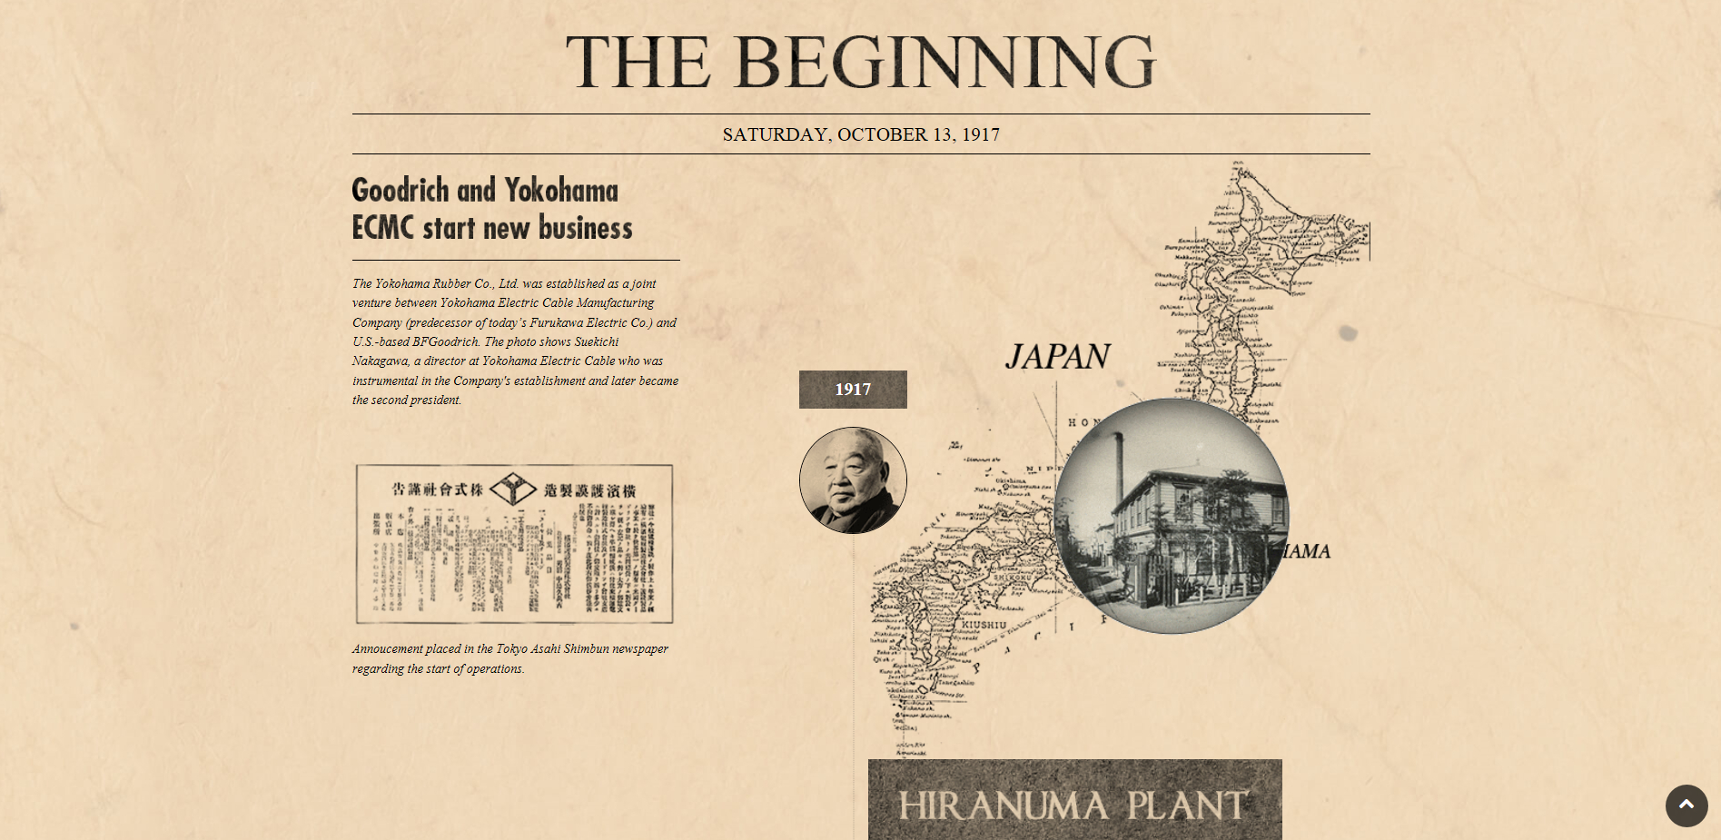

*The Beginning YOKOHAMA Europe Special Anniversary celebration*

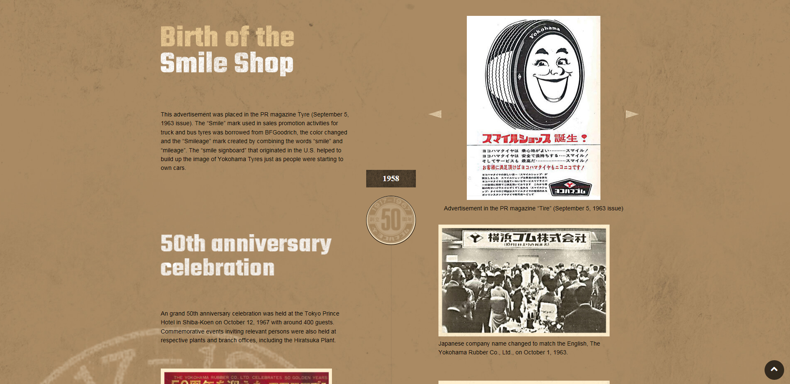

*YOKOHAMA '50s and '60s*

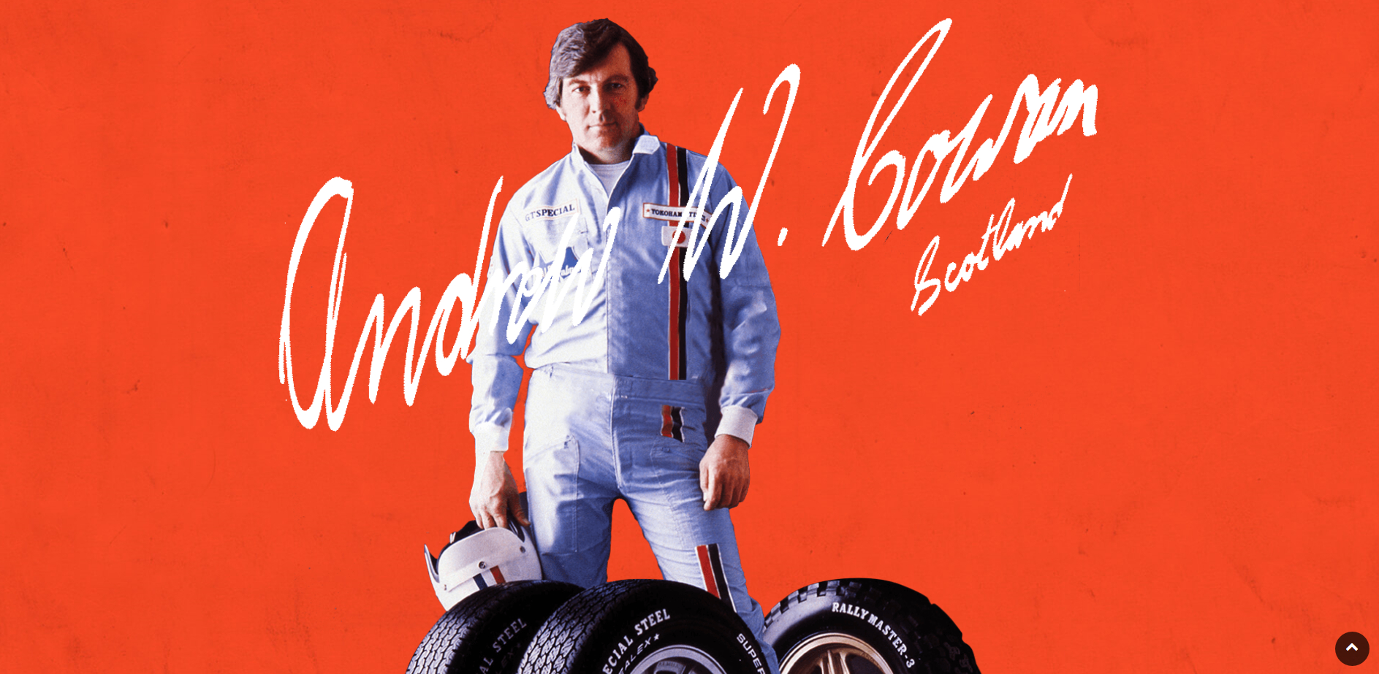

*Motorsports in YOKOHAMA's DNA Special Anniversary micro-site*

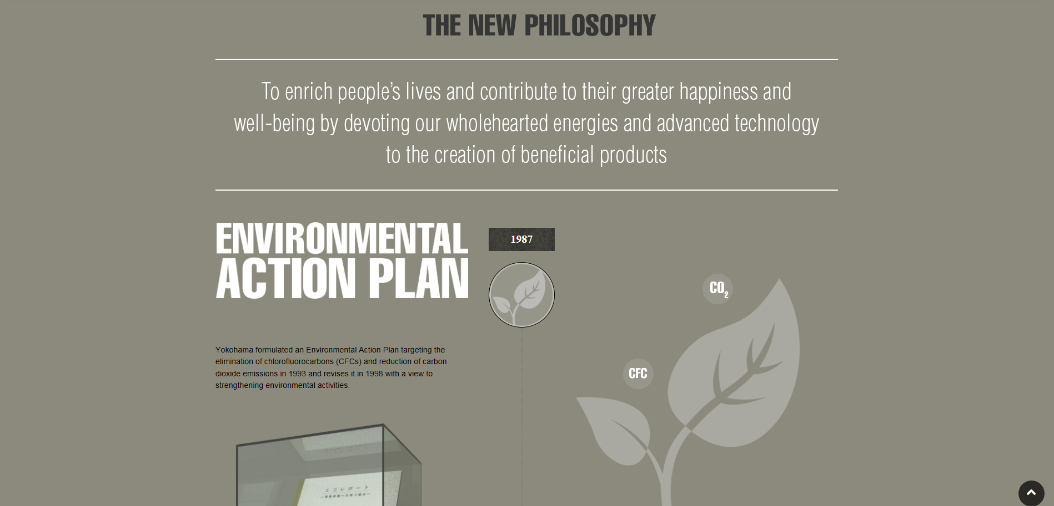

*YOKOHAMA and the Environment*

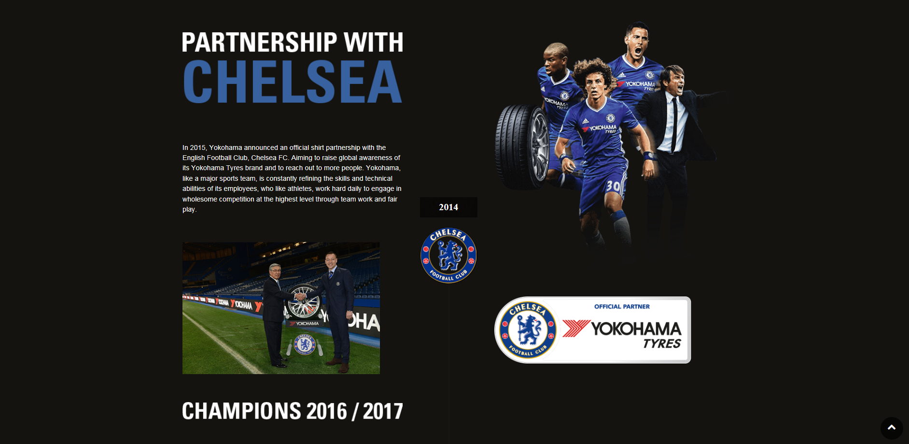

*Partnership with Chelsea FC*